**Using Node.js to Connect to GCS MySQL Instance**

**Objective**

* Setting up Node.js environment
* Connecting to GCS MySQL Instance
* Retrieving records from database
* Inserting records into database
* Updating records on the database
* Deleting records from the database

**Findings**

* node.js is middleware between the client and database server
* used npm to install node.js and mysql module
* First Attempt - Rejected by server error…
  + *Client does not support authentication protocol requested by server; consider upgrading MySQL client*
* Seems like I have to create a proxy instance with json key authentication
  + ./cloud_sql_proxy -instances=INSTANCE_CONNECTION_NAME=tcp:3306
* Whitelisted my test IP to connect directly with GCS DB
  + Environment:
  + node.js
  + npm
* I was able to connect to DB from test system cmd prompt

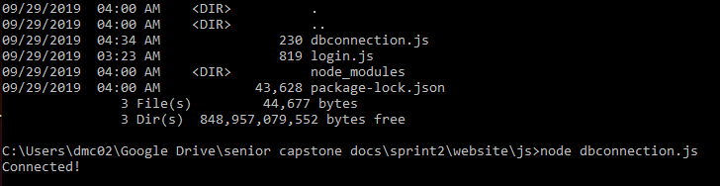

**Node.JS Script I used:**

var mysql = require('mysql');

var con = mysql.createConnection({

host: "localhost",

user: "yourusername",

password: "yourpassword"

});

con.connect(function(err) {

if (err) throw err;

console.log("Connected!");

});

*host=[InstanceIP];user=”[DBadmin]”;password=”[AdminPW]”’*

**Conclusion**

Powerful server side framework for DB connectivity. It is necessary to secure DB credentials in a secure file that is not shared with public repositories.